Advanced Machine Learning

Heriberto Cuayahuitl

23 February 2022

Introduction – Reinforcement Learning

Module Overview: Synopsis and Learning Outcomes

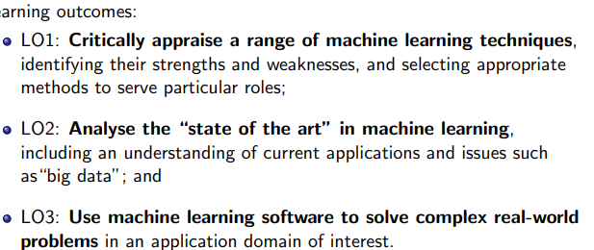

Assessments:

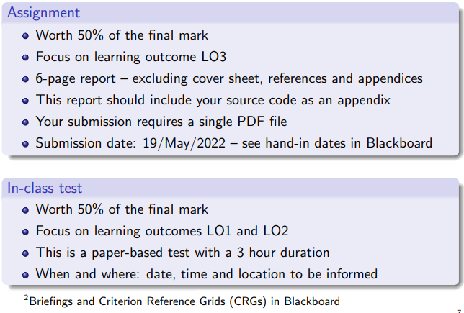

**What is Machine Learning?**

The study of computer algorithms that improve automatically through experience.

A computer program is said to learn from experience E with respect to some class of tasks T and performance measure P if its performance at tasks in T, as measured by P, improves with experience E.

When a problem outputs values between 0 and 1 we call them probabilistic classifiers.

**Types of Machine Learning: Reinforcement Learning**

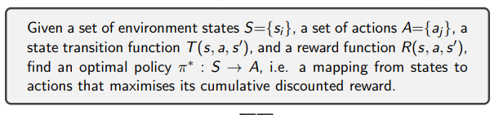

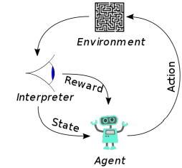

**Elements of Reinforcement Learning**

An agent interacts with its environment, senses it to decide on its state, takes an action to modify its state, and receives a reward.

An agent can be described as a Markov Decision Process (MDP) with states S, actions A, state transition function T = P(s’|s, a), and reward function R = P(r’|s, a)

